3/28/2021

Daniel Ewers

DAT602 Project

Milestone One

Table of Contents

Game Description 4

Game Concept 4

Form Navigation 4

Live Game Play 4

Player registration 4

Game administration functions 4

Confirmation for a game 5

Player selection 5

Gameplay 5

Main objective and Scoring 5

Sketches 6

Storyboards 8

**storyboard 1** – game opening form 8

**storyboard 2** – Login 8

**storyboard 3** – register account 9

**storyboard 4** – main lobby for users 9

**storyboard 5** – main lobby for administrators 10

**storyboard 6** – game menu (options) 10

**storyboard 7** – administrator settings 11

**storyboard 8** – leader board 12

**storyboard 9** – game form 12

**storyboard 10** – Admin creates new user 13

**Storyboard 11 –** Admin edits existing user 13

**storyboard 12** – game confirmation (new game) 14

**storyboard 13** – game confirmation (join existing game) 14

**storyboard 14 –** Incorrect username or password 15

**storyboard 15** – Username ALready Exists 15

**storyboard 16** – Change user information 15

**storyboard 17** – Confirm deletion 16

**storyboard 18** – Leave confirmation 16

**storyboard 19** – Congratulations (Game finished) 16

**storyboard 20** – Congratulations (Picked up asset) 17

Screen Design Rationale 18

Login/Sign Up Screens 18

Home Lobby Screen 18

Leader board Screen 18

Game Lobby Screen 18

Game Screen 18

Administrative Settings Screen 19

Logical ERD 0

C.R.U.D Table 0

Usage Scenarios 1

User Creates an account 1

User Deletes account 1

User Creates a character 1

User Creates a game 1

User leaves game and Rejoins game 1

User moves in game 1

User finishes game 2

Admin opens settings interface 2

Admin Creates a User account 2

Admin deletes a player 2

Admin updates a current player 2

Admin ends game 2

Admin resets game 2

DDL SQL 3

**Create Table Procedure** 3

**INSERT** 5

**UPDATE** 10

**SELECT** 15

**DELETE** 18

Milestone One

# Game Description

### Game Concept

I have come up with a concept for a multiplayer game that follows the idea of navigating a maze. The objective of the game is to start the game at the home tile and navigate through a variety of different pathways to reach the mazes exit. Throughout the maze will be randomly generated items that give the player extra points. There will be points given based on the order of completion of the maze. First place would get 100 points, second 75, third 50, and so on. You may choose to be the quickest to reduce the risk of losing points, or you could take your time to collect items at the expense of not being the fastest through. If you choose to go slowly, you may find yourself loosing points due to landing on trap tiles.

### Form Navigation

There will be several different forms within the application. This will include login forms, administrator settings, game creation and gameplay forms. These will be accessed by clicking sequences of buttons that will take you to different forms. This navigation will be simple and intuitive to give the best user experience. The user will start with a main form that give them two options of logging in or signing up. Once completed, they will then find themselves in the main menu of the game. This will display different options depending on whether the user is an administrator or not. The game creation form will display currently active games and options for users to create, reconnect, and refresh games, as well as the player selection. Administrative options will give the admin powers to do a range of different things such as deleting players, assign administrative privileges, stop games, and restart the games.

### Live Game Play

When a user is in a game, they can see other players that are nearby. This will allow the user to follow them, possibly take points from them, or scare them off. The games will continue to run when a player has left allowing the other users to continue with their game. This will stop the disruption of the gameplay.

### Player registration

As stated before, the user will first open a form that gives the user an option to log in or sign up. The game will implement a registration feature that allows a user to sign up with a username, password, email, first name and last name. By allowing them to input an email and username, it gives them an option to use either when they want to log in. This stops them from being locked out of their accounts if they have forgotten their username.

### Game administration functions

A user that has administrator rights has the privileges to perform a variety of different tasks. This includes such things as resetting a player score, removing the player from the database, unlocking a locked account, change a user password, give administrator rights, end a current game, or restart the game. This allows us management of games and players within the game. The benefit of this is so we can stop games that don’t have players in it.

### Confirmation for a game

When a user creates a new game, a simple popup box will alert the user to tell them that they have successfully created a game. There will be an additional popup when a user clicks the button to join an existing game. This will allow them to accept or decline the game just in case it was a miss click.

### Player selection

When you go to join a game, create one, or join back to your existing game, there is an option to choose what colour you player will be. This will be a set list of different colours that you can choose from. The colour you pick will be displayed within the maze representing your player. This will help you identify yourself and where you are in the maze.

### Gameplay

The user will start the game located at the home tile. They will have a set of controls (Up, down. Left, right) that will allow them to navigate through the maze. This will be single movements from tile to tile. They will have a small window where they can see around them limiting their vision of the maze. They will navigate through the maze looking for items to gain additional points, or rush for the exit. The player will want to have the best luck not to land on random chance tiles that could potentially take away their points. Once a player is satisfied with the items that they have collected, they can exit the maze. There will also be rare items within the maze that are kept with the user indefinitely. These will give the user special abilities for future games.

### Main objective and Scoring

The main objective of the game is to exit the maze with as many points as you can. This is because there will be a leader board that displays the statistics of the players. The better your score, the higher you will be placed on the leader board. This will be based off total score, games played, and average score across the total games. You can choose how you decide to get points whether it be collecting items or racing for the end. Whatever you choose to get points, the main objective is to finish the maze with these points.

# Sketches

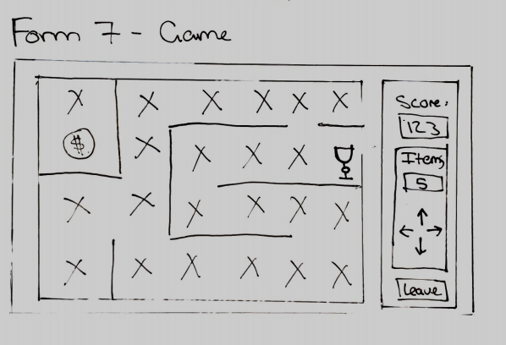

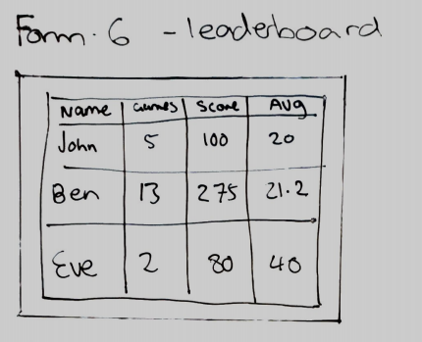

The first step to creating my game was the planning phase. I decided to start off by brainstorming possible ideas of possible games that would meet the requirements of the assessment. Each game had different ideas branching from them of possible ways of making it a multiplayer game or other ideas within the game. I also planned out what forms might be found within the application. This helped me gain an understanding of what I would need to implement to meet the specifications of the app.

# Storyboards

From my initial sketches, I made each form using Adobe XD. This gave me a better understanding of how the final product may look like. These are not the final design of the forms as I may come across some additional or redundant features further down the line.

|  |
| --- |
| **storyboard 1** – game opening form |
|  |
| 1.1 Button that takes user to storyboard two  1.2 Button that takes user to storyboard three |
| **storyboard 2** – Login |
|  |
| 2.1 Input field for the user to input their username or password  2.2 Input field where a user can input their password  2.3 confirmation button which sends the information to the database and returns a result. If the username or password is incorrect, storyboard fourteen opens. If the user is an administrator, the user is taken to storyboard five. If the user is a regular player, they are redirected to storyboard four.  2.4 Button that takes the user back to storyboard one |
| **storyboard 3** – register account |
|  |
| 3.1 Input field where a user can input a username  3.2 Input field where a user can input a password  3.3 Input field where a user can input their email address  3.4 Confirmation button which sends the information to the database and returns a result. If the username is already taken, storyboard fifteen opens. If the information is accepted, the user is taken to storyboard four.  3.5 Button that takes the user back to storyboard one |
| **storyboard 4** – main lobby for users |
|  |
| 4.1 Button that takes user to storyboard six  4.2 Button that takes user to storyboard eight  4.3 Button that takes user to storyboard seventeen |
| **storyboard 5** – main lobby for administrators |
|  |
| 5.1 Button that takes administrator to storyboard  5.2 Button that takes administrator to storyboard |
| **storyboard 6** – game menu (options) |
|  |
| 6.1 List box of all active players in the game. Users can join the games of these active players.  6.2 Button that takes user to storyboard thirteen  6.3 Button that takes user to storyboard  6.4 Active player item in the list  6.5 Button that takes user to storyboard thirteen  6.6 Button that takes user to storyboard  6.7 Combo box that allows a user to select their character  6.8 Button that refreshes the active player list |
| **storyboard 7** – administrator settings |
|  |
| 7.1 Combo box for the administrator to select a user from the list  7.2 Button that resets the players score to zero in the database  7.3 Button that removes all records of a user in the database  7.4 Button that takes administrator to storyboard eleven  7.5 Tick box that gives the user administrative rights. This updates the user_isAdmin item in the database to true or false  7.6 Tick box that locks or unlocks a users account. This updates the user_accountStatus item in the database to locked or unlocked.  7.7 Button that takes administrator to storyboard ten  7.8 List box of active games. The items can be set to active by clicking on them. This allows the admin to choose what game they want to edit.  7.9 Button that takes administrator to storyboard five  7.10 Button that removes all records of a game in the database  7.11 Button that resets all records of a game in the database |

|  |
| --- |
| **storyboard 8** – leader board |
|  |
| 8.1 Grid box that contains the leader board  8.2 Button that takes user to storyboard five  8.3 Column for usernames  8.4 Column for games played. This updates when a game is played  8.5 Column for game score. This updates when a game is played  8.6 Column for average score. This updates when a game is played |
| **storyboard 9** – game form |
|  |
| 9.1 Asset tile. This can be occupied by any player. If a user clicks it, they receive the item and changes it to a regular tile. On clicking the tile, this opens storyboard twenty  9.2 Score of the current player. This increases as a player collects more items and progresses through the maze.  9.3 Number of items that a player is carrying.  9.4 Player tile. This cannot be occupied by another player while you are on it  9.5 Empty Tile. This can be occupied by any player  9.6 Display of controls to show the user how to play the game  9.7 Button that takes user to storyboard eighteen  9.8 Chat list displays text when user submits it by clicking the send button  9.9 Button that sends the text within the text field to the chat and displays it in the list  9.10 Input field where a user types the message |
| **storyboard 10** – Admin creates new user |
|  |
| 7.5.1 Button that takes user to storyboard five  7.5.2 Input field for the admin to input a username  7.5.3 Input field for the admin to input a password  7.5.4 Input field for the admin to input an email  7.5.5 Text box for the admin to check if they want the user to be an admin  7.5.6 Confirmation button which sends the information to the database and returns a result. If the username is already taken, storyboard fifteen opens. If the information is accepted, the administrator is taken back to storyboard seven. |
| **Storyboard 11 –** Admin edits existing user |
|  |
| 7.4.1 Button that takes user to storyboard five  7.4.2 Input field for the admin to input a username  7.4.3 Input field for the admin to input a password  7.4.4 Input field for the admin to input an email  7.4.5 Text box for the admin to check if they want the user to be an admin  7.4.6 Confirmation button which sends the information to the database and returns a result. If the username is already taken, storyboard fifteen opens. If the information is accepted, the administrator is taken to storyboard sixteen. |
| **storyboard 12** – game confirmation (new game) |
|  |
| 6.6.1 Button that creates a new game in the database. In doing so, this removes all previous game records that this user has created. This then sends the user to storyboard nine.  6.6.2 This button cancels the user’s actions and returns them to storyboard six |
| **storyboard 13** – game confirmation (join existing game) |
|  |
| 6.2.1 Button that takes user to storyboard nine  6.2.2 This button cancels the user’s actions and returns them to storyboard six |
| **storyboard 14 –** Incorrect username or password |
|  |
| 2.3.1 Button that closes box and returns the user to storyboard two |
| **storyboard 15** – Username ALready Exists |
|  |
| 11.1 Returns to storyboard three for users or storyboard ten for administrators |
| **storyboard 16** – Change user information |
|  |
| 7.4.6.1 This button updates any changes to the database then returns the user to storyboard seven  7.4.6.2 This button cancels the administrator’s actions and returns them to storyboard seven |
| **storyboard 17** – Confirm deletion |
|  |
| 10.1 This deletes all records of the user from the database. If they are a user, they are returned to storyboard one. If they are an admin, they return to storyboard seven  10.2 This button cancels the actions and returns them to storyboard seven if they are an admin or storyboard four for users. |
| **storyboard 18** – Leave confirmation |
|  |
| 9.7.1 Saves the users current position and returns them to storyboard six  9.7.2 Cancels the user’s actions and returns them to storyboard nine |
| **storyboard 19** – Congratulations (Game finished) |
|  |
| 12 Stores the new data in then database and returns the user to storyboard six |
| **storyboard 20** – Congratulations (Picked up asset) |
|  |
| 9.1.1 Updates the users inventory then returns the user to storyboard nine |

# Screen Design Rationale

### Login/Sign Up Screens

I wanted to create a simplistic design that was aimed at achieving the required goal without trying to create something unique. Quite often it is better to go with what users are use too rather than creating something new. Therefor, I design simple login and sign up screens that are simple and intuitive for the user. Due to the requirements of the assessment, I designed it so that if the username already exists or the password is incorrect, error boxes appear to notify the user. If the username doesn’t exist, they have the option to open the sign-up form instead. This gives them the option to create a new account.

### Home Lobby Screen

I decided that I wanted to create a simple home screen so that the login step doesn’t take the user straight to the game lobby. I like this idea as I can display a variety of different options such as the leader board button, settings button, delete button, and game button. I added the minor touch of the “Dungeons and Players” versus the “Dungeons and Administrators” as a bit of a gimmick to identify the different user interfaces. This subtle change gives the users a simple change in interface. In doing this, I also changed what options the users and admins have as the settings button would be redundant for an ordinary user.

### Leader board Screen

I decided to add a leader board with a simplistic design that is intuitive for the users with simple headings and a basic grid layout. The idea for this is to make it efficient for the user when they want to look for their details in the leader board. It only displays what I believe as to be the necessary information, that being username, games played, overall score, and average score. The purpose of the leader board is for users to compete to reach the higher positions and view other people scores. In the top right is a home button that takes the user to the home lobby screen. This was a gey element as the user needs to back out of the page if they did not wish to access it.

### Game Lobby Screen

The game lobby was designed with the systems requirements in mind. I started off by planning what is needed for the assessment. I created a simple list on the left that displays all the active users in their game. This gives users the option to join these pre-existing games. In the centre is where we find the basic options. These being continue game, new game, colour (character) selection, and refresh games. These were placed here as the central region is where you would generally place the key elements. To the right is a field that displays the game type you are playing. This is a nice feature as it adds design to the overall page.

### Game Screen

The game screen was design with the idea of keeping the key element in the centre. This is so that the user can keep their focus on the centre rather than looking off to the side. The elements on the game screen are bold so that it is easy for the user to identify features. I placed the player information on the left-hand side as we tend to find the chat on the right of games (as seen in my design). Like other features throughout my app, I wanted to keep to the general layout convention of apps as they are a lot more intuitive than coming up with potentially confusing ideas.

### Administrative Settings Screen

Like the other screens, the administrative screen was design with simplicity and intuitiveness in mind. I originally had the settings split into two screens based on their purpose. I decided to combine it into one screen as this increases the efficiency of game management for the administrators. The elements within the form are large and bold so that they are easy to read while keeping uniform shapes.

As stated in the assessment, the requirements for the administrative settings is for them to kill games, add new players, update existing players, or remove players. I added a drop down that displays all the player accounts. This allows the admin to select a player that they want to manage. From here they can delete the player, reset the player, modify player details, give admin privileges, or unlock account. This meets the requirements for the player management. There is a button at the bottom that opens a screen to create a new player account. This meets the requirements of adding new players. On the right side we have a list of active games. When the admin selects the game, they can then end the game or reset the game. This meets the requirements to kill active games.

For the create user, I reused the sign-up form with the addition of the give admin tick box. This keeps a informality across the forms.

# Logical ERD

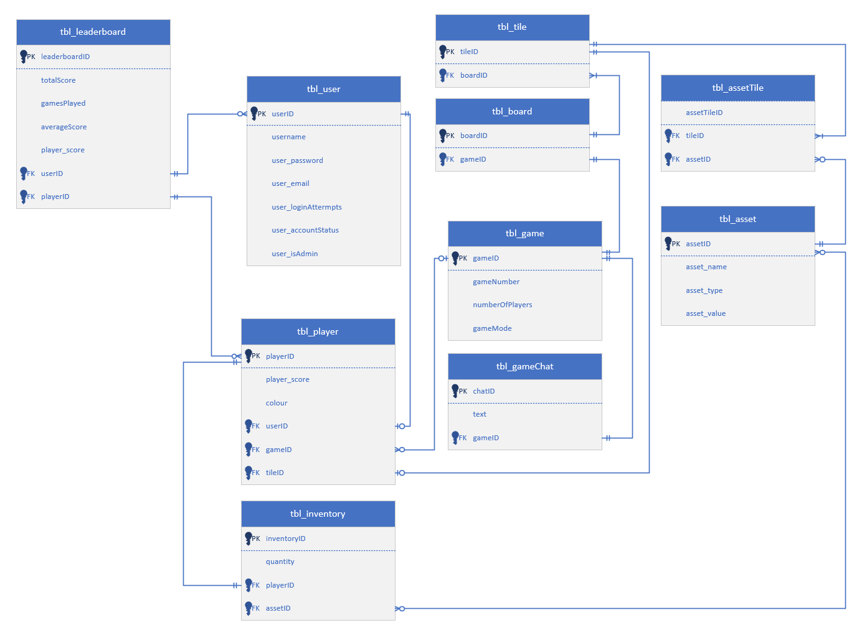

# C.R.U.D Table

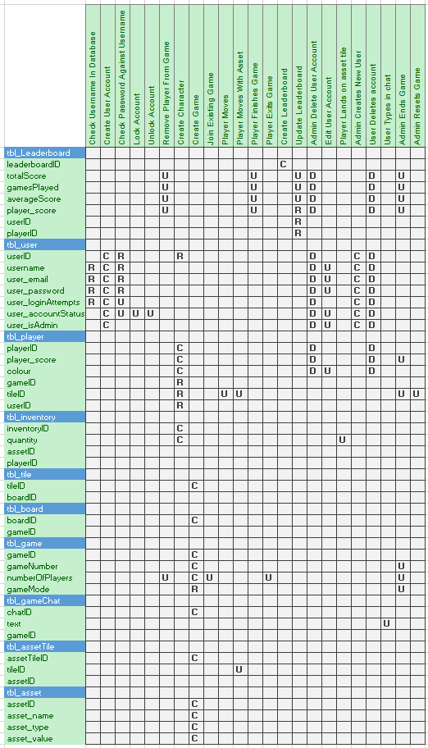

# Usage Scenarios

### User Creates an account

A new user will click the sign-up button. This will open a form that allows a user to enter a username, password, and their email. This gives them two options when it comes to logging in. When a user enters a username, the system will check to see if this is already taken. If the username is not taken, they will be prompt to enter a password then alerted that they will be creating a new user account. If the player name is an existing name, the player is prompted for a password and the password they submit is checked to see if that password is correct. After five tries the player is locked out, and an administrator email is presented. On accepting the new users account, they will be added to the list of online players. If an existing player succeeds at logging in, the player’s name and details are added to the list of players online

### User Deletes account

A user has an option to delete their account from the home page. This is represented by a trash can icon. This will prompt a dialogue box for the user to confirm the deletion of their account. If they choose yes, this will redirect them back to the login/sign up page. Upon deleting the account, all records of the user will be removed from the database. They will no longer be able to login to that account. In doing so, this will allow that username to be used. The other option is to cancel if they do not wish to delete their account

### User Creates a character

In the game menu, the user has the option to select between a range of different characters. These are represented by a range of pre-set colours that will display as a coloured circle when you play the game. There will be a limited number of characters to choose from as there will be a set limit of players in the games. The user is not limited to the same character every game, they can pick a different character each time if that character is available.

### User Creates a game

In the game menu, a user can choose to create a game. When they click the new game button, they will be met with a popup dialogue box. This will ask them if they are sure if they want to create a game. If they choose too to create a game, the previous game they created will be removed (to reduce the overall amount of games). They will then be directed to the game screen. The player moves around the maze from one tile to another, collecting items, competing with other players who are playing within the same tiled maze.

### User leaves game and Rejoins game

When a player leaves the game, their current state is kept in the database. When the player returns to the game the player, if the tile they were on is currently empty, they return to the tile on the map they were on when they left the game, otherwise the player must choose a different neighbouring tile to continue playing the game.

### User moves in game

Players start on the “Home Tile”. Apart from the “Home tile” only one player can be placed on each tile at time. The player who achieves the first “click” on an empty tile moves to that tile. Once on a tile the player can click on the items on that tile to gain or lose points. When a player moves from the tile, the tile becomes empty. The current tile that the user is on is stored within the database for future reference. If the player has an asset in their inventory, the asset tile ID will update as the player moves around the board.

### User finishes game

When the user has made it to the end of the maze, their points will be added to the leader board. This will add to the total points as well as calculating the average score. Additionally, the number of games played will increase by one. If the user does not finish the game, the total number of games played will still increase having a negative impact on their statistics.

### Admin opens settings interface

When the admin clicks the setting button, this will open an interface that displays a series of different options for managing player accounts, creating new accounts, and managing games. This will include such things as ending games and deleting accounts, to giving administrative rights.

### Admin Creates a User account

When the admin clicks the plus button, a window will pop up that looks the same as the sign-up form (with the addition of a give admin rights check box). This will allow an admin to create an account for a user. On completion, the new user account details will be added to the database. Like the user sign up form, the admin will be prompted with the same error messages if there is duplicate data.

### Admin deletes a player

Unlike the users that can only delete their own account, an admin has the option to delete any account that ahs been created. They will be prompted with the same popup for them to confirm the deletion. If they choose to delete the player, all records of that user will be removed from the database.

### Admin updates a current player

Within the admin controls, the admin has the power to update information about the user. This includes changing their username, password, email, giving admin rights, or account status (if they are locked out). Like the other admin controls, a popup box will allow the admin to confirm or cancel these changes.

### Admin ends game

The admin has rights to end any game that is in progress. If they choose to do so, all records of that game will be removed, and the players will be kicked from the game. This will remove the game from the list of active players. Like the other admin controls, a popup box will allow the admin to confirm or cancel this action.

### Admin resets game

The admin also has the rights to reset a game. This will move all players back to the start of the game and set their score to zero. In doing so, the map will also rest. This will refresh the assets on the map. Players will then have to restart the game. Like the other admin controls, a popup box will allow the admin to confirm or cancel this action.

# DDL SQL

## **Create Table Procedure**







## **INSERT**

#### tbl_asset



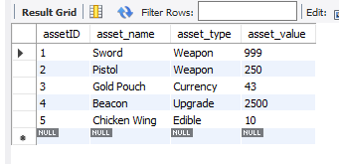

#### tbl_game



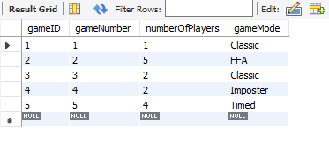

#### tbl_board



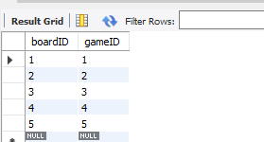

#### tbl_tile



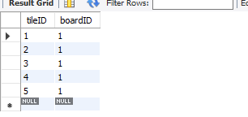

#### tbl_assetTile



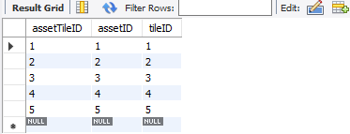

#### tbl_gamechat



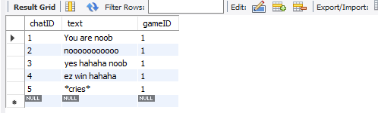

#### tbl_user



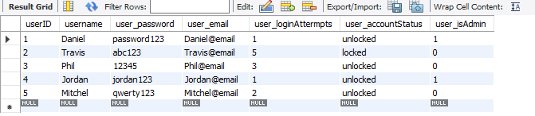

#### tbl_player



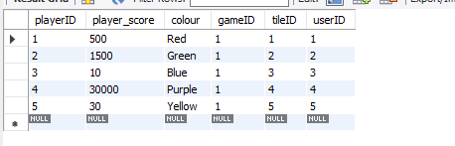

#### tbl_inventory



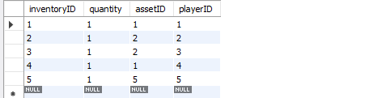

#### tbl_leaderboard



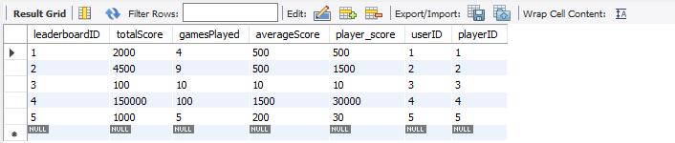

## **UPDATE**

#### **tbl_asset**



**Before**



**After**

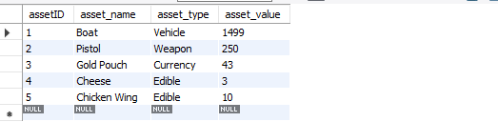

#### **tbl_game**



**Before**



**After**

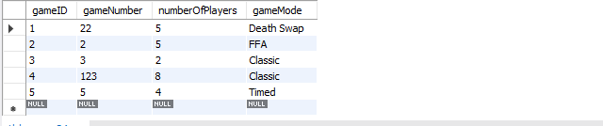

#### **tbl_board**



**Before**



**After**

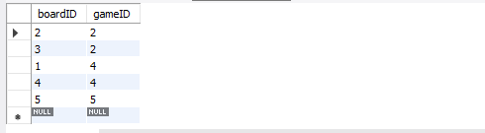

#### **tbl_tile**



**Before**



**After**

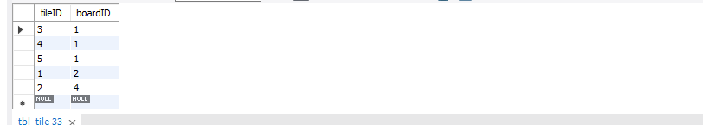

#### **tbl_assetTile**



**Before**



**After**

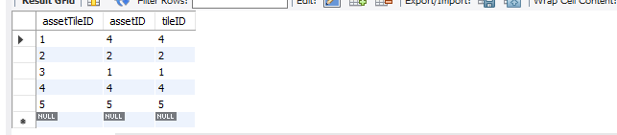

#### **tbl_gamechat**



**Before**



**After**

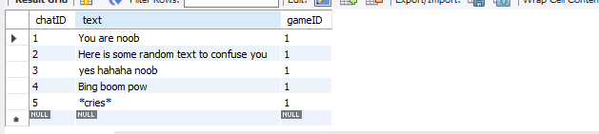

#### **tbl_user**



**Before**



**After**

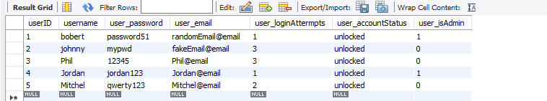

#### **tbl_player**



**Before**



**After**

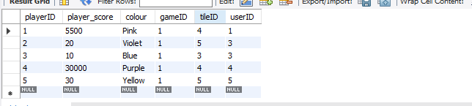

#### **tbl_inventory**



**Before**



**After**

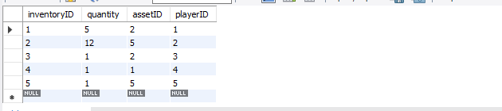

#### **tbl_leaderboard**



**Before**



**After**

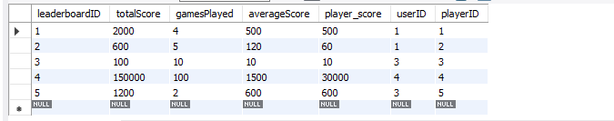

## **SELECT**

#### tbl_leaderboard and tbl_user



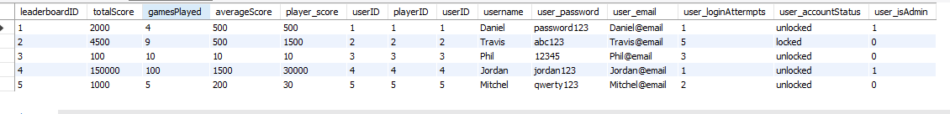

#### tbl_inventory and tbl_player



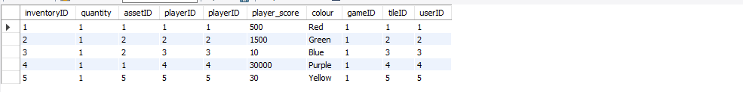

#### tbl_player and tbl_user



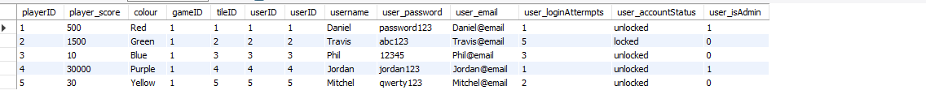

#### tbl_game and tbl_player



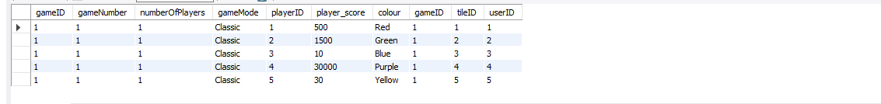

#### tbl_player and tbl_tile



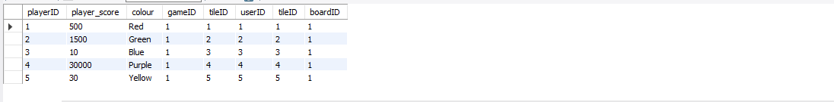

#### tbl_assetTile and tbl_tile



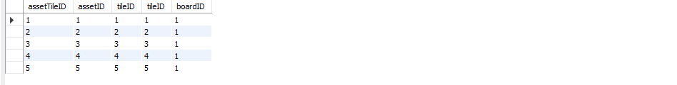

#### tbl_board and tbl_tile



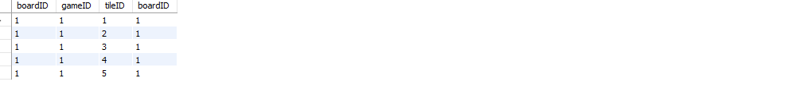

#### tbl_board and tbl_game



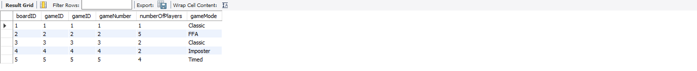

#### tbl_game and tbl_gamechat



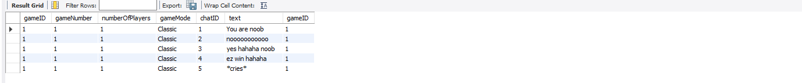

#### tbl_asset and tbl_assetTile





#### tbl_asset and tbl_inventory





## **DELETE**

#### tbl_leaderboard



**Before**

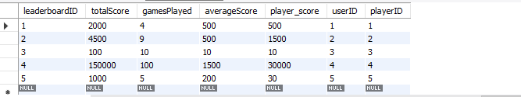

**After**

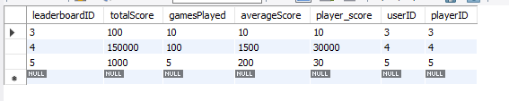

#### tbl_user



**Before**

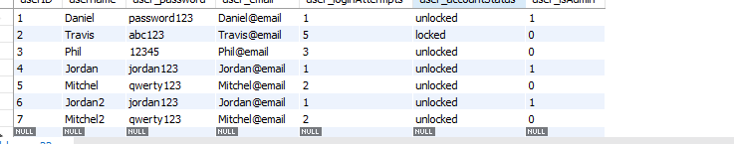

**After**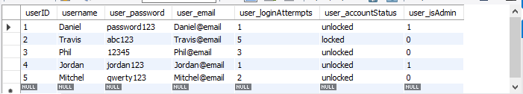

#### tbl_player



**Before**

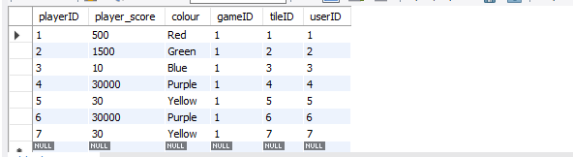

**After**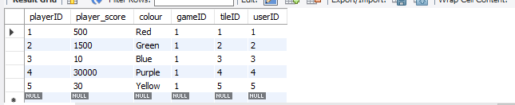

#### tbl_inventory



**Before**

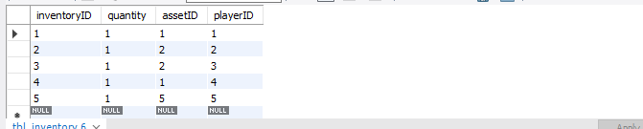

**After**

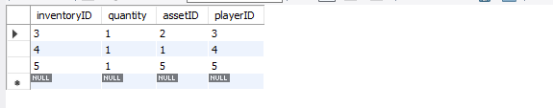

#### tbl_tile



**Before**

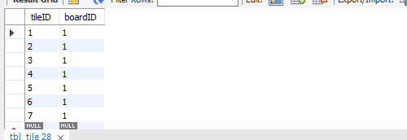

**After**

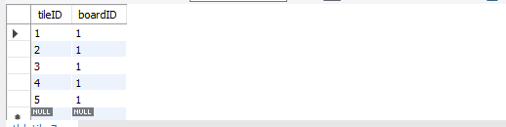

#### tbl_board



**Before**

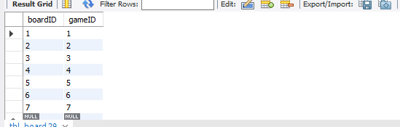

**After**

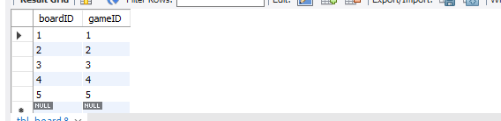

#### tbl_game



**Before**

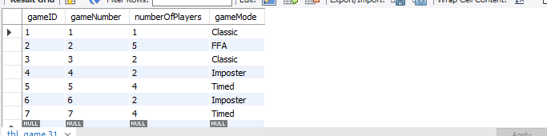

**After**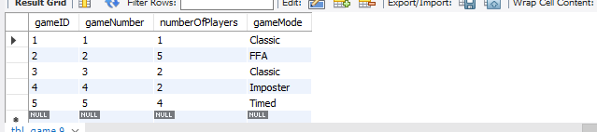

#### tbl_gameChat



**Before**

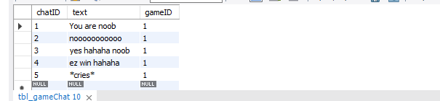

**After**

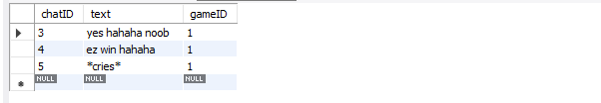

#### tbl_assettile



**Before**

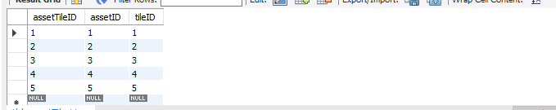

**After**

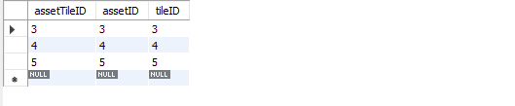

#### tbl_asset



**Before**

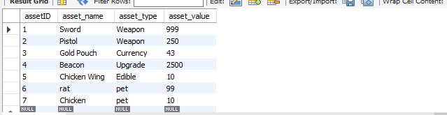

**After**

